Linear BLDC Motor Model

- The modeled 3-Phase BLDC Motor is a Custom Motor Example, which was tested in the Lab and the measurements’ results was compared with the simulation. Some parameters are different than on the real physical example. This note is related to the real values of the Jm-Motor Inertia and the Dm-Viscose Dumping Coefficient. They was not clearly defined for the Motor prototype for that reason they was iterative found from many measurements during the test.

- The Model is based on the theoretical linear differential equations of the BLDC Motor using its preliminary electrical and mechanical parameters.

- The MotorTest01.asc … MotorTest05.asc schematic files are examples for different type of Controls, from Trapezoidal to Analog including Sinusoidal Control too. In the example file MotorTest01.asc the Hall Sensor’s Outputs are directly connected to the 3-Phase PWM Logic Circuitry, which drives a 3-Phase Bridge. In other examples the phasing of the PWM and Analog 3-Phase Signal is related to the Shaft’s Angular Position. The Motor is running up to the maximum possible speed limited by its electrical (BEMF) and mechanical dynamic (Friction) parameters and the source Voltage. By using controlled Bridges, there is a requirement to set-up the right timing for the Top and Bottom Gate signals (to eliminate cross fires). The dead-times between Top and Bottom side Gate Voltages (TA … TC, BA… BC) are defined by the values of the R1-C1, R2-C2 RCs. The PWM source in these examples was sat-up to 100% Duty Cycle to make possible to compare results between different configurations and to see, which variables are influencing them. Of course these bridges can be built by using MOSFET-s (or IGBT-s).

- The PWM Logic Circuitry is “not public” ☺, for that reason its code is encrypted.

- The BLDC Motor Model is open source documentation in BLDC.Lib file. It makes possible to analyze the system in relation to the appropriate block diagrams below. To experiment with different parameters of the Motor Model use the conventions given by LTspice in the Component Attribute Editor (for example: R=0.5 or R={R} … etc.)

- The SK_Friction.asc file is only a math example how to define Start and Kinetic Friction for the Motor’s Shaft. Lines from 09 to 13 can be ignored or modified but do not Delete SK_Friction.asc File! If so, the appropriate line, including the subcircuit reference must be eliminated from the BLDC.Lib file.

01 * D:\Simulation\BLDC Motor\LTspice\TK_FRICTION.asy
02 * Modified LTSpice Netlist Created : 9/12/2009
03 * ---------------------------------------------
04 * Description: Start/Kynetic Friction
05 * ---------------------------------------------
06 .subckt SK_Friction w Tx Tf
07 R1 Tx 0 1G
08 R2 w 0 1G
09 .param b=10 c=.01 Tfs=0.005 Tfk=0.0045
10 B0 Tf0 0 V=abs(V(Tx))*b/(b+c+abs(V(w)))
11 B1 Tf1 0 V=Tfk*(1-1/(1+Tfk*abs(V(w))))
12 B2 Tf2 0 V=V(Tf0)+V(Tf1)
13 B3 Tf 0 V=-sgn(V(w))*if(V(Tf2)>=Tfs, Tfs, V(Tf2))
14 .ends SK_Friction
15 *
16 * End of Subcircuit Created from : TK_FRICTION.asc

Installation:

- Files: MotorTest01…05.asc, BLDC.asy, Driverx.asc, Driverx.asy, Switch3.asy
copy into any Folder for simulation.

- Files: BLDC.Lib, BLDCSupport.Lib, SK_Friction.mod copy into LTspice’s
… /sub Folder.

Note: The Model of BLDC Motor is based mostly on the behavioral B-sources,
consequently the simulation is very slow! Be patient! ☺

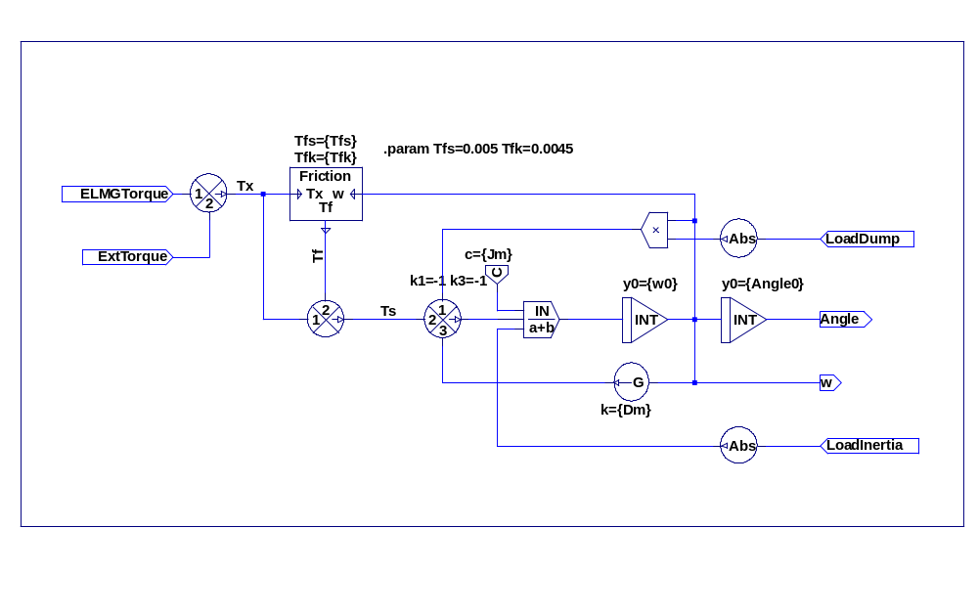
Block Diagram of the Mechanical Stage
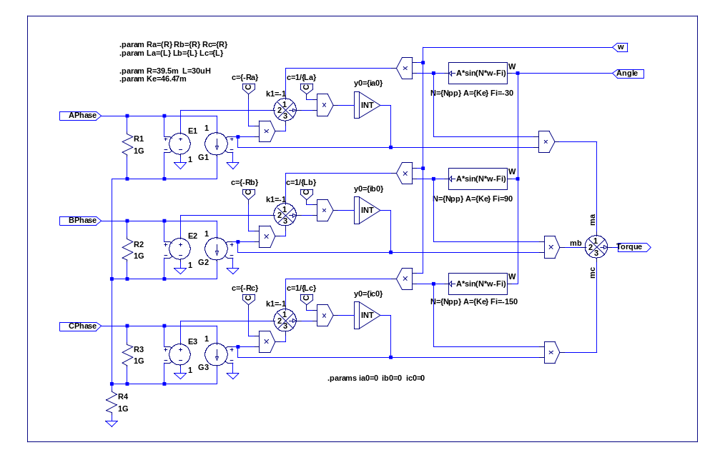
Block Diagram of the Electric Stage

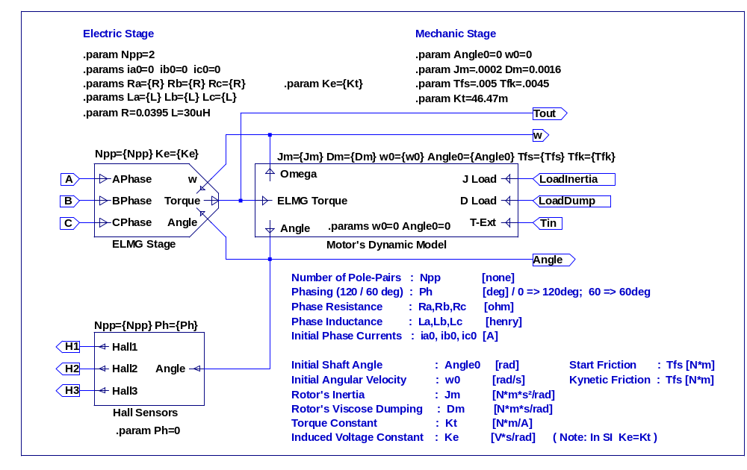
Block Diagram of the 3 Phase BLDC Motor

Peter Kapas Ventura, California 09/12/2009

